Thermal Power Plant

At present 54.09% or 93918.38 MW (Data Source CEA, as on 31/03/2011) of total electricity production in India is from Coal Based Thermal Power Station. A coal based thermal power plant converts the chemical energy of the coal into electrical energy. This is achieved by raising the steam in the boilers, expanding it through the turbine and coupling the turbines to the generators which converts mechanical energy into electrical energy.

[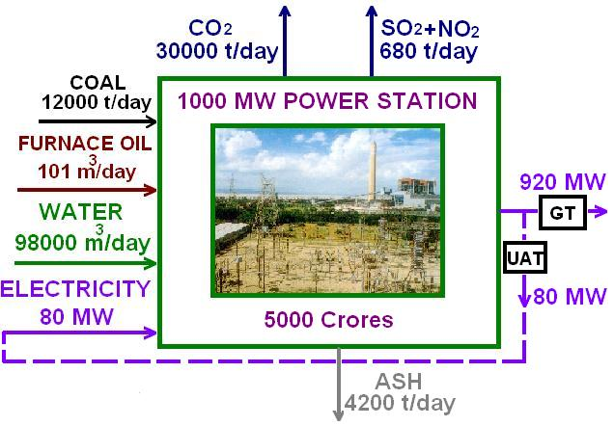](http://indianpowersector.com/home/?attachment_id=1739)

**Introductory overview**

In a coal based power plant coal is transported from coal mines to the power plant by railway in wagons or in a merry-go-round system. Coal is unloaded from the wagons to a moving underground conveyor belt. This coal from the mines is of no uniform size. So it is taken to the Crusher house and crushed to a size of 20mm. From the crusher house the coal is either stored in dead storage( generally 40 days coal supply) which serves as coal supply in case of coal supply bottleneck or to the live storage(8 hours coal supply) in the raw coal bunker in the boiler house. Raw coal from the raw coal bunker is supplied to the Coal Mills by a Raw Coal Feeder. The Coal Mills or pulverizer pulverizes the coal to 200 mesh size. The powdered coal from the coal mills is carried to the boiler in coal pipes by high pressure hot air. The pulverized coal air mixture is burnt in the boiler in the combustion zone.  
Generally in modern boilers tangential firing system is used i.e. the coal nozzles/ guns form tangent to a circle. The temperature in fire ball is of the order of 1300 deg.C. The boiler is a water tube boiler hanging from the top. Water is converted to steam in the boiler and steam is separated from water in the boiler Drum. The saturated steam from the boiler drum is taken to the Low Temperature Superheater, Platen Superheater and Final Superheater respectively for superheating. The superheated steam from the final superheater is taken to the High Pressure Steam Turbine (HPT). In the HPT the steam pressure is utilized to rotate the turbine and the resultant is rotational energy. From the HPT the out coming steam is taken to the Reheater in the boiler to increase its temperature as the steam becomes wet at the HPT outlet. After reheating this steam is taken to the Intermediate Pressure Turbine (IPT) and then to the Low Pressure Turbine (LPT). The outlet of the LPT is sent to the condenser for condensing back to water by a cooling water system. This condensed water is collected in the Hotwell and is again sent to the boiler in a closed cycle. The rotational energy imparted to the turbine by high pressure steam is converted to electrical energy in the Generator.

***Diagram of a typical coal-fired thermal power station***

[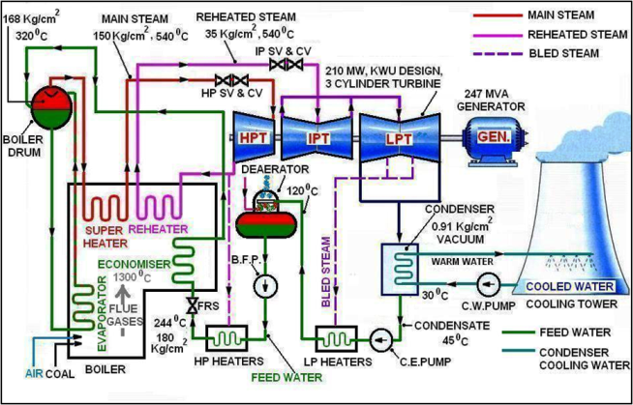](http://indianpowersector.com/home/?attachment_id=1738)

**Principal**

Coal based thermal power plant works on the principal of Modified Rankine Cycle.

[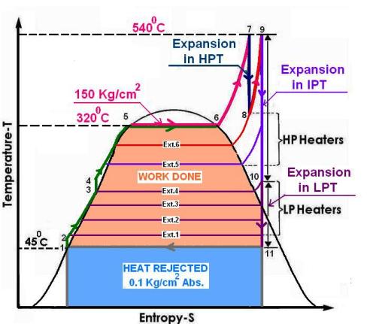](http://indianpowersector.com/home/?attachment_id=1740)

**Advantages of coal based thermal Power Plant**

* They can respond to rapidly changing loads without difficulty
* A portion of the steam generated can be used as a process steam in different industries
* Steam engines and turbines can work under 25 % of overload continuously
* Fuel used is cheaper
* Cheaper in production cost in comparison with that of diesel power stations

**Disadvantages of coal based thermal Power Plant**

* Long time required for erection and putting into  action
* A large quantity of water is required
* Great difficulty experienced in coal handling
* Presence of troubles due to smoke and heat in the plant
* Unavailability of good quality coal
* Maximum of  heat  energy lost
* Problem of ash removing

Nuclear Power Plant

[inShare](javascript:void(0);)3

**Nuclear power** is the fourth-largest source of electricity in India after thermal, hydro and renewable sources of electricity. As of 2010, India has 19 nuclear power plants in operation generating 4,560 MW while 4 other are under construction and are expected to generate an additional 2,720 MW. India is also involved in the development of fusion reactors through its participation in the ITER project.

Since early 1990s, Russia has been a major source of nuclear fuel to India. Due to dwindling domestic uranium reserves, electricity generation from nuclear power in India declined by 12.83% from 2006 to 2008. Following a waiver from the Nuclear Suppliers Group in September 2008 which allowed it to commence international nuclear trade, India has signed nuclear deals with several other countries including France, United States,United Kingdom, Canada, Namibia, Mongolia, Argentina, Kazakhstan In February 2009, India also signed a $700 million deal with Russia for the supply of 2000 tons nuclear fuel

India now envisages to increase the contribution of nuclear power to overall electricity generation capacity from 4.2% to 9% within 25 years. In 2010, India’s installed nuclear power generation capacity will increase to 6,000 MW. As of 2009, India stands 9th in the world in terms of number of operational nuclear power reactors and is constructing 9 more, including two EPRs being constructed by France’s Areva. Indigenous atomic reactors include TAPS-3, and -4, both of which are 540 MW reactors.India’s $717 million fast breeder reactor project is expected to be operational by 2010.

**Nuclear Power Growth in India**

**Growth**

India, being a non-signatory of the Nuclear Non-Proliferation Treaty, has been subjected to a defacto nuclear embargo from members of the Nuclear Suppliers Group (NSG) cartel. This has prevented India from obtaining commercial nuclear fuel, nuclear power plant components and services from the international market, thereby forcing India to develop its own fuel, components and services for nuclear power generation. The NSG embargo has had both negative and positive consequences for India’s Nuclear Industry. On one hand, the NSG regime has constrained India from freely importing nuclear fuel at the volume and cost levels it would like to support the country’s goals of expanding its nuclear power generation capacity to at least 20,000 MW by 2020. Also, by precluding India from taking advantage of the economies of scale and safety innovations of the global nuclear industry, the NSG regime has driven up the capital and operating costs and damaged the achievable safety potential of Indian nuclear power plants. On the other hand, the NSG embargo has forced the Indian government and bureaucracy to support and actively fund the development of Indian nuclear technologies and industrial capacities in all key areas required to create and maintain a domestic nuclear industry. This has resulted in the creation of a large pool of nuclear scientists, engineers and technicians that have developed new and unique innovations in the areas of Fast Breeder Reactors, Thermal Breeder Reactors, the Thorium fuel cycle, nuclear fuel reprocessing and Tritium extraction & production. Ironically, had the NSG sanctions not been in place, it would have been far more cost effective for India to import foreign nuclear power plants and nuclear fuels than to fund the development of Indian nuclear power generation technology, building of India’s own nuclear reactors, and the development of domestic uranium mining, milling and refining capacity.

The Indian nuclear power industry is expected to undergo a significant expansion in the coming years thanks in part to the passing of The Indo-US nuclear deal. This agreement will allow India to carry out trade of nuclear fuel and technologies with other countries and significantly enhance its power generation capacity. when the agreement goes through, India is expected to generate an additional 25,000 MW of nuclear power by 2020, bringing total estimated nuclear power generation to 45,000 MW.

India has already been using imported enriched uranium and are currently under International Atomic Energy Agency (IAEA) safeguards, but it has developed various aspects of the nuclear fuel cycle to support its reactors. Development of select technologies has been strongly affected by limited imports. Use of heavy water reactors has been particularly attractive for the nation because it allows Uranium to be burnt with little to no enrichment capabilities. India has also done a great amount of work in the development of a Thorium centered fuel cycle. While Uranium deposits in the nation are limited there are much greater reserves of Thorium and it could provide hundreds of times the energy with the same mass of fuel. The fact that Thorium can theoretically be utilized in heavy water reactors has tied the development of the two. A prototype reactor that would burn Uranium-Plutonium fuel while irradiating a Thorium blanket is under construction at the Madras/Kalpakkam Atomic Power Station.

Just as many conventional thermal power stations generate electricity by harnessing the thermal energy released from burning fossil fuels, nuclear power plants convert the energy released from the nucleus of an atom, typically via nuclear fission.

When a relatively large fissile atomic nucleus (usually uranium-235 or plutonium-239) absorbs a neutron, a fission of the atom often results. Fission splits the atom into two or more smaller nuclei with kinetic energy (known as fission products) and also releases gamma radiation and free neutrons. A portion of these neutrons may later be absorbed by other fissile atoms and create more fissions, which release more neutrons, and so on.

This nuclear chain reaction can be controlled by using neutron poisons and neutron moderators to change the portion of neutrons that will go on to cause more fissions. Nuclear reactors generally have automatic and manual systems to shut the fission reaction down if unsafe conditions are detected.

A cooling system removes heat from the reactor core and transports it to another area of the plant, where the thermal energy can be harnessed to produce electricity or to do other useful work. Typically the hot coolant will be used as a heat source for a boiler, and the pressurized steam from that boiler will power one or more steam turbine driven electrical generators.

There are many different reactor designs, utilizing different fuels and coolants and incorporating different control schemes. Some of these designs have been engineered to meet a specific need. Reactors for nuclear submarines and large naval ships, for example, commonly use highly enriched uranium as a fuel. This fuel choice increases the reactor’s power density and extends the usable life of the nuclear fuel load, but is more expensive and a greater risk to nuclear proliferation than some of the other nuclear fuels.

A number of new designs for nuclear power generation, collectively known as the Generation IV reactors, are the subject of active research and may be used for practical power generation in the future. Many of these new designs specifically attempt to make fission reactors cleaner, safer and/or less of a risk to the proliferation of nuclear weapons. Passively safe plants (such as the ESBWR) are available to be built and other designs that are believed to be nearly fool-proof are being pursued. Fusion reactors, which may be viable in the future, diminish or eliminate many of the risks associated with nuclear fission.

**Flexibility of nuclear power plants**

It is often claimed that nuclear stations are inflexible in their output, implying that other forms of energy would be required to meet peak demand. While that is true for certain reactors, this is no longer true of at least some modern designs.

Nuclear plants are routinely used in load following mode on a large scale in France.

Boiling water reactors normally have load-following capability, implemented by varying the recirculation water flow.

**Life cycle**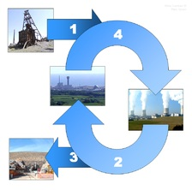

The nuclear fuel cycle begins when uranium is mined, enriched, and manufactured into nuclear fuel, (1) which is delivered to a nuclear power plant. After usage in the power plant, the spent fuel is delivered to a reprocessing plant (2) or to a final repository (3) for geological disposition. In reprocessing 95% of spent fuel can be recycled to be returned to usage in a power plant (4).

A nuclear reactor is only part of the life-cycle for nuclear power. The process starts with mining . Uranium mines are underground, open-pit, or in-situ leach mines. In any case, the uranium ore is extracted, usually converted into a stable and compact form such as yellowcake, and then transported to a processing facility. Here, the yellowcake is converted to uranium hexafluoride, which is then enriched using various techniques. At this point, the enriched uranium, containing more than the natural 0.7% U-235, is used to make rods of the proper composition and geometry for the particular reactor that the fuel is destined for. The fuel rods will spend about 3 operational cycles (typically 6 years total now) inside the reactor, generally until about 3% of their uranium has been fissioned, then they will be moved to a spent fuel pool where the short lived isotopes generated by fission can decay away. After about 5 years in a cooling pond, the spent fuel is radioactively and thermally cool enough to handle, and it can be moved to dry storage casks or reprocessed.

**Conventional fuel resources**

Uranium is a fairly common element in the Earth’s crust. Uranium is approximately as common as tin or germanium in Earth’s crust, and is about 35 times more common than silver. Uranium is a constituent of most rocks, dirt, and of the oceans. The fact that uranium is so spread out is a problem because mining uranium is only economically feasible where there is a large concentration. Still, the world’s present measured resources of uranium, economically recoverable at a price of 130 USD/kg, are enough to last for “at least a century” at current consumption rates. This represents a higher level of assured resources than is normal for most minerals. On the basis of analogies with other metallic minerals, a doubling of price from present levels could be expected to create about a tenfold increase in measured resources, over time. However, the cost of nuclear power lies for the most part in the construction of the power station. Therefore the fuel’s contribution to the overall cost of the electricity produced is relatively small, so even a large fuel price escalation will have relatively little effect on final price. For instance, typically a doubling of the uranium market price would increase the fuel cost for a light water reactor by 26% and the electricity cost about 7%, whereas doubling the price of natural gas would typically add 70% to the price of electricity from that source. At high enough prices, eventually extraction from sources such as granite and seawater become economically feasible.

Current light water reactors make relatively inefficient use of nuclear fuel, fissioning only the very rare uranium-235 isotope. Nuclear reprocessing can make this waste reusable and more efficient reactor designs allow better use of the available resources.

**Breeding**

As opposed to current light water reactors which use uranium-235 (0.7% of all natural uranium), fast breeder reactors use uranium-238 (99.3% of all natural uranium). It has been estimated that there is up to five billion years’ worth of uranium-238 for use in these power plants.

Breeder technology has been used in several reactors, but the high cost of reprocessing fuel safely requires uranium prices of more than 200 USD/kg before becoming justified economically. As of December 2005, the only breeder reactor producing power is BN-600 in Beloyarsk, Russia. The electricity output of BN-600 is 600 MW — Russia has planned to build another unit, BN-800, at Beloyarsk nuclear power plant. Also, Japan’s Monju reactor is planned for restart (having been shut down since 1995), and both China and India intend to build breeder reactors.

Another alternative would be to use uranium-233 bred from thorium as fission fuel in the thorium fuel cycle. Thorium is about 3.5 times as common as uranium in the Earth’s crust, and has different geographic characteristics. This would extend the total practical fissionable resource base by 450%. Unlike the breeding of U-238 into plutonium, fast breeder reactors are not necessary — it can be performed satisfactorily in more conventional plants. India has looked into this technology, as it has abundant thorium reserves but little uranium.

**Fusion**

Fusion power advocates commonly propose the use of deuterium, or tritium, both isotopes of hydrogen, as fuel and in many current designs also lithium and boron. Assuming a fusion energy output equal to the current global output and that this does not increase in the future, then the known current lithium reserves would last 3000 years, lithium from sea water would last 60 million years, and a more complicated fusion process using only deuterium from sea water would have fuel for 150 billion years. Although this process has yet to be realized, many experts and civilians alike believe fusion to be a promising future energy source due to the short lived radioactivity of the produced waste, its low carbon emissions, and its prospective power output.

**Solid waste**

The most important waste stream from nuclear power plants is spent nuclear fuel. It is primarily composed of unconverted uranium as well as significant quantities of transuranic actinides (plutonium and curium, mostly). In addition, about 3% of it is fission products from nuclear reactions. The actinides (uranium, plutonium, and curium) are responsible for the bulk of the long-term radioactivity, whereas the fission products are responsible for the bulk of the short-term radioactivity.

**High-level radioactive waste**

After about 5 percent of a nuclear fuel rod has reacted inside a nuclear reactor that rod is no longer able to be used as fuel (due to the build-up of fission products). Today, scientists are experimenting on how to recycle these rods so as to reduce waste and use the remaining actinides as fuel (large-scale reprocessing is being used in a number of countries).

A typical 1000-MWe nuclear reactor produces approximately 20 cubic meters (about 27 tonnes) of spent nuclear fuel each year (but only 3 cubic meters of vitrified volume if reprocessed). All the spent fuel produced to date by all commercial nuclear power plants in the US would cover a football field to the depth of about one meter.

Spent nuclear fuel is initially very highly radioactive and so must be handled with great care and forethought. However, it becomes significantly less radioactive over the course of thousands of years of time. After 40 years, the radiation flux is 99.9% lower than it was the moment the spent fuel was removed from operation, although the spent fuel is still dangerously radioactive at that time.[51] After 10,000 years of radioactive decay, according to United States Environmental Protection Agency standards, the spent nuclear fuel will no longer pose a threat to public health and safety.

When first extracted, spent fuel rods are stored in shielded basins of water (spent fuel pools), usually located on-site. The water provides both cooling for the still-decaying fission products, and shielding from the continuing radioactivity. After a period of time (generally five years for US plants), the now cooler, less radioactive fuel is typically moved to a dry-storage facility or dry cask storage, where the fuel is stored in steel and concrete containers. Most U.S. waste is currently stored at the nuclear site where it is generated, while suitable permanent disposal methods are discussed.

As of 2007, the United States had accumulated more than 50,000 metric tons of spent nuclear fuel from nuclear reactors. Permanent storage underground in U.S. had been proposed at the Yucca Mountain nuclear waste repository, but that project has now been effectively cancelled – the permanent disposal of the U.S.’s high-level waste is an as-yet unresolved political problem.

The amount of high-level waste can be reduced in several ways, particularly nuclear reprocessing. Even so, the remaining waste will be substantially radioactive for at least 300 years even if the actinides are removed, and for up to thousands of years if the actinides are left in. Even with separation of all actinides, and using fast breeder reactors to destroy by transmutation some of the longer-lived non-actinides as well, the waste must be segregated from the environment for one to a few hundred years, and therefore this is properly categorized as a long-term problem. Subcritical reactors or fusion reactors could also reduce the time the waste has to be stored. It has been argued[*who?*] that the best solution for the nuclear waste is above ground temporary storage since technology is rapidly changing. Some people believe that current waste might become a valuable resource in the future.

According to a 2007 story broadcast on *60 Minutes*, nuclear power gives France the cleanest air of any industrialized country, and the cheapest electricity in all of Europe. France reprocesses its nuclear waste to reduce its mass and make more energy. However, the article continues, “Today we stock containers of waste because currently scientists don’t know how to reduce or eliminate the toxicity, but maybe in 100 years perhaps scientists will… Nuclear waste is an enormously difficult political problem which to date no country has solved. It is, in a sense, the Achilles heel of the nuclear industry… If France is unable to solve this issue, says Mandil, then ‘I do not see how we can continue our nuclear program. Further, reprocessing itself has its critics, such as the Union of Concerned Scientists.

**Low-level radioactive waste**

The nuclear industry also produces a huge volume of low-level radioactive waste in the form of contaminated items like clothing, hand tools, water purifier resins, and (upon decommissioning) the materials of which the reactor itself is built. In the United States, the Nuclear Regulatory Commission has repeatedly attempted to allow low-level materials to be handled as normal waste: landfilled, recycled into consumer items, et cetera. Most low-level waste releases very low levels of radioactivity and is only considered radioactive waste because of its history.

**Comparing radioactive waste to industrial toxic waste**

In countries with nuclear power, radioactive wastes comprise less than 1% of total industrial toxic wastes, much of which remains hazardous indefinitely. Overall, nuclear power produces far less waste material by volume than fossil-fuel based power plants. Coal-burning plants are particularly noted for producing large amounts of toxic and mildly radioactive ash due to concentrating naturally occurring metals and mildly radioactive material from the coal. A recent report from Oak Ridge National Laboratory concludes that coal power actually results in more radioactivity being released into the environment than nuclear power operation, and that the population effective dose equivalent from radiation from coal plants is 100 times as much as from ideal operation of nuclear plants. Indeed, coal ash is much less radioactive than nuclear waste, but ash is released directly into the environment, whereas nuclear plants use shielding to protect the environment from the irradiated reactor vessel, fuel rods, and any radioactive waste on site.

**Reprocessing**

Reprocessing can potentially recover up to 95% of the remaining uranium and plutonium in spent nuclear fuel, putting it into new mixed oxide fuel. This produces a reduction in long term radioactivity within the remaining waste, since this is largely short-lived fission products, and reduces its volume by over 90%. Reprocessing of civilian fuel from power reactors is currently done on large scale in Britain, France and (formerly) Russia, soon will be done in China and perhaps India, and is being done on an expanding scale in Japan. The full potential of reprocessing has not been achieved because it requires breeder reactors, which are not yet commercially available. France is generally cited as the most successful reprocessor, but it presently only recycles 28% (by mass) of the yearly fuel use, 7% within France and another 21% in Russia.

Unlike other countries, the US stopped civilian reprocessing from 1976 to 1981 as one part of US non-proliferation policy, since reprocessed material such as plutonium could be used in nuclear weapons: however, reprocessing is not allowed in the U.S.In the U.S., spent nuclear fuel is currently all treated as waste.

In February, 2006, a new U.S. initiative, the Global Nuclear Energy Partnership was announced. It is an international effort aimed to reprocess fuel in a manner making nuclear proliferation unfeasible, while making nuclear power available to developing countries.

**Depleted uranium**

Uranium enrichment produces many tons of depleted uranium (DU) which consists of U-238 with most of the easily fissile U-235 isotope removed. U-238 is a tough metal with several commercial uses—for example, aircraft production, radiation shielding, and armor—as it has a higher density than lead. Depleted uranium is also controversially used in munitions; DU penetrators (bullets or APFSDS tips) “self sharpen”, due to uranium’s tendency to fracture along shear bands.

Hydro Power Plant

[inShare](javascript:void(0);)2

**Overview**

In hydroelectric power plants the potential energy of water due to its high location is converted into electrical energy. The total power generation capacity of the hydroelectric power plants depends on the head of water and volume of water flowing towards the water turbine.  
It is the most widely used form of renewable energy. Once a hydroelectric complex is constructed, the project produces no direct waste, and has a considerably lower output level of the greenhouse gas carbon dioxide (CO2) than fossil fuel powered energy plants.

India was one of the pioneering countries in establishing hydro-electric power plants. The power plant at Darjeeling and Shimsha (Shivanasamudra) was established in 1898 and 1902 respectively and is one of the first in Asia. The installed capacity as on**31st March ’2011** was approximately **37567.40MW i.e 21.64%***(source CEA)*. Out of total hydro generation the state sector contribute the highest 27257.00MW, followed by PSU’s with capacity of 8885.40MW while the private sector accounts for only 1425.00MW (source CEA as on 31st march 2011).

The hydroelectric power plant, also called as dam or hydropower plant, is used for generation of electricity from water on large scale basis. The dam is built across the large river that has sufficient quantity of water throughout the river. In certain cases where the river is very large, more than one dam can built across the river at different locations.

**Working Principle of Hydroelectric Power Plant**

The water flowing in the river possesses two type of energy: the kinetic energy due to flow of water and potential energy due to the height of water. In hydroelectric power plants or dams potential energy of water is utilized to generate electricity.

The formula for total power that can be generated from water in hydroelectric power plant due to its height is given by

**P = rhg**

Where: P is the total power that can be produced in watts

**r**- is the flow rate of water measured in cubic meters per second.

**h**- is called height of water measured in meters. It is also head of water. It is difference in height between the source of water (from where water is taken) and the water’s outflow (where the water is used to generate electricity, it is the place near the turbines).

**g**- is the gravity constant 9.81 m/second square

The formula clearly shows that the total power that can be generated from the hydroelectric power plants depends on two major factors: the flow rate of water or volume of flow of water and height or head of water. More the volume of water and more the head of water more is the power produced in the hydroelectric power plant.

To obtain the high head of water the reservoir of water should as high as possible and power generation unit should be as low as possible. The maximum height of reservoir of water is fixed by natural factors like the height of river bed, the amount of water and other environmental factors. The location of the power generation unit can be adjusted as per the total amount of power that is to be generated. Usually the power generation unit is constructed at levels lower than ground level so as to get the maximum head of water.

The total flow rate of water can be adjusted through the penstock as per the requirements. If more power is to be generated more water can be allowed to flow through it.

**Generating methods**

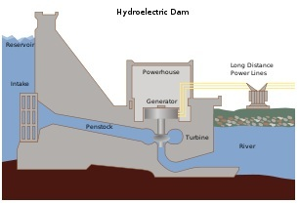

*Cross section of a conventional hydroelectric dam.*

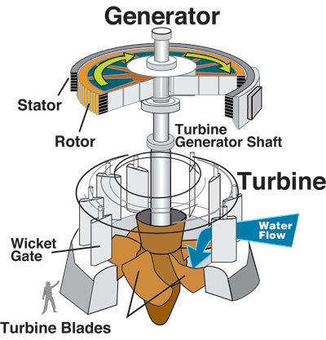

*A typical turbine and generator*

**Conventional**

Most hydroelectric power comes from the potential energy of dammed water driving a water turbine and generator. The power extracted from the water depends on the volume and on the difference in height between the source and the water’s outflow. This height difference is called the head. The amount of potential energy in water is proportional to the head. To deliver water to a turbine while maintaining pressure arising from the head, a large pipe called a penstock may be used.

**Pumped-storage**

This method produces electricity to supply high peak demands by moving water between reservoirs at different elevations. At times of low electrical demand, excess generation capacity is used to pump water into the higher reservoir. When there is higher demand, water is released back into the lower reservoir through a turbine. Pumped-storage schemes currently provide the most commercially important means of large-scale grid energy storage and improve the daily capacity factor of the generation system.

**Run-of-the-river**

Run-of-the-river hydroelectric stations are those with comparably smaller reservoir capacities, thus making it impossible to store water.

**Tide**

A tidal power plant makes use of the daily rise and fall of water due to tides; such sources are highly predictable, and if conditions permit construction of reservoirs, can also be dispatchable to generate power during high demand periods. Less common types of hydro schemes use water’s kinetic energy or undammed sources such as undershot waterwheels.

**Layout of Hydroelectric Power Plants**

Hydroelectric power plants convert the hydraulic potential energy from water into electrical energy. Such  plants are suitable were water with suitable *head*are available. The layout covered in this article is just a simple one and only cover the important parts of  hydroelectric plant.The different parts of  a hydroelectric power plant are

(**1) Dam**  
Dams are structures built over rivers to stop the water flow and form a reservoir.The reservoir stores the water flowing down the river. This water is diverted to turbines in power stations. The dams collect water during the rainy season and stores it, thus allowing for a steady flow through the turbines throughout the year. Dams are also used for controlling floods and irrigation. The dams should be water-tight and should be able to withstand the pressure exerted by the water on it. There are different types of dams such as arch dams, gravity dams and buttress dams. The height of water in the dam is called *head race*.

**(2) Spillway**  
A spillway as the name suggests could be called as a way for spilling of water from dams. It is  used to provide for the release of flood water from a dam. It is used to prevent over toping of the dams which could result in damage or failure of  dams. Spillways could be controlled type or uncontrolled type. The uncontrolled types start releasing water upon water rising above a particular level. But in case of the controlled type, regulation of flow is possible.

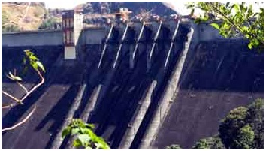

**(3) Penstock and Tunnel**  
Penstocks are pipes which carry water from the reservoir to the turbines inside power station. They are usually made of  steel and are equipped with gate systems.Water under high pressure flows through the penstock. A tunnel serves the same purpose as a penstock. It is used when an obstruction is present between the dam and power station such as a mountain.

* Pressure  Shaft/penstock  is  enclosed  pipe/channel  used  to  deliver/feed water  to  hydraulic  turbines  in  respect  of hydro power plant.
* Pressure tunnels must be kept  far below the lowest possible hydraulic gradient  to  avoid, the creation of  vacuum and the consequent risks of unstable flow, cavitation and collapse of lining.
* Total  friction  losses  in  the  tunnel must  not be great enough  to  impair  the output and  the  regulation of machines.

**(4) Power house**

Power house  is a  station  for generation of electricity.  It  houses equipment and personnel working  in a  power generating station.

Essential components of the power house are:

a)  Machine hall.

b)  Unloading and erection bay.

c)  Annexes or Extensions

d)  Passages or ducts for cables, bus-bars and pipes

e)  Control room

f)  Workshop

g)  Storage space

h)  Office and administrative accommodation.

**(5) Generating Equipment**

*DESIGNING.*

Estimating total capacity of Plant

1) Head Available: Firm and Secondary   Power

2) Load Factor: Industrial and Domestic  Load

3) Cost Estimate: Capital Charges + Depreciation + O&M

4) Revenue to be expected.

Estimating No. Of Generating Sets

1) Cost of Initial Installation.

2) Cost of Operation.

3) Reliability of Supply.

a) Isolated distribution system

b) Interconnected system.

4) Shaft arrangement

5)Auxiliary plant

**(6) HYDRO TURBINES**

Classified into two categories:

*Impulse Turbine*

1.  Uses the velocity of  water to move the runner & discharges to atmospheric  pressure.

2.  The water stream hits each bucket on the runner.

3.  There is no suction on the down side of the turbine.

4.  Water flows out the bottom of the turbine housing after hi tting the runner.

5.  Generally suitable for high head, low flow applications.

*Reaction Turbine*

Develops power from the combined action of pressure and moving water

Runner  is  placed  directly  in  the  water  stream  flowing  over  the  blades  rather  than  striking  each individually

Used for sites with lower head and higher flows

**Advantages**

* Renewable, non-radioactive & non-polluting source of Energy
* Reliable, clean and efficient Energy Source.
* Low cost of generation
* Low operation & maintenance charges
* Inherent ability for quick starting, stopping & instantaneous load acceptance/ rejection
* Meet peak load requirement.
* Avoided Green House Gas (GHG) emissions from equivalent thermal and other fuel based power projects
* Increase in Agriculture Productivity through development of irrigation and multipurpose schemes
* Flood Mitigation through large storage dams

**Disadvantages**

* Ecosystem damage and loss of land
* Siltation
* Flow shortage
* Methane emissions (from reservoirs)
* Relocation
* Failure hazard

# 